**Lab: S3 Bucket Creation and File Upload - GUI**

**Services Used: S3**

1. Go to S3 Service in AWS Console
2. In S3 Service click Buckets 🡪 Create Bucket

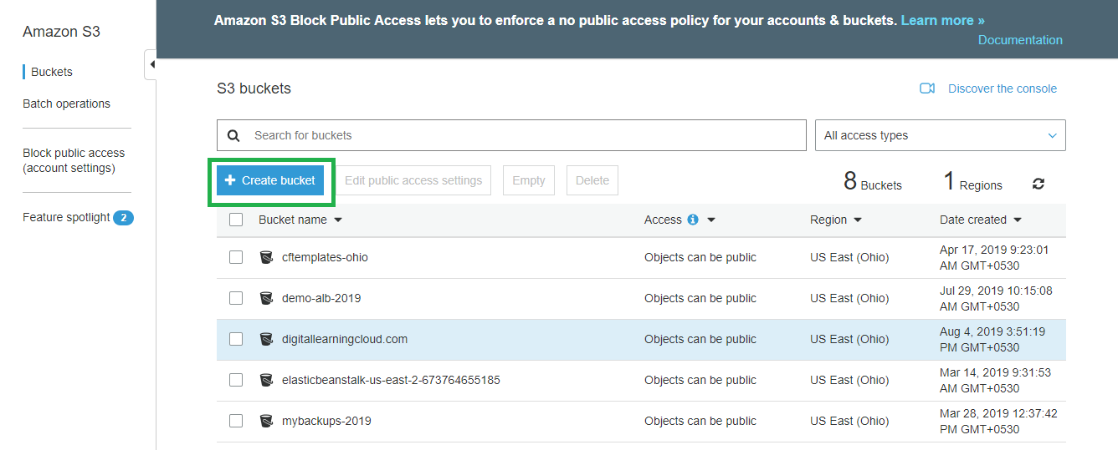

1. Provide unique bucket name and select the region. Click Next to continue. If you click create default settings will be applied.

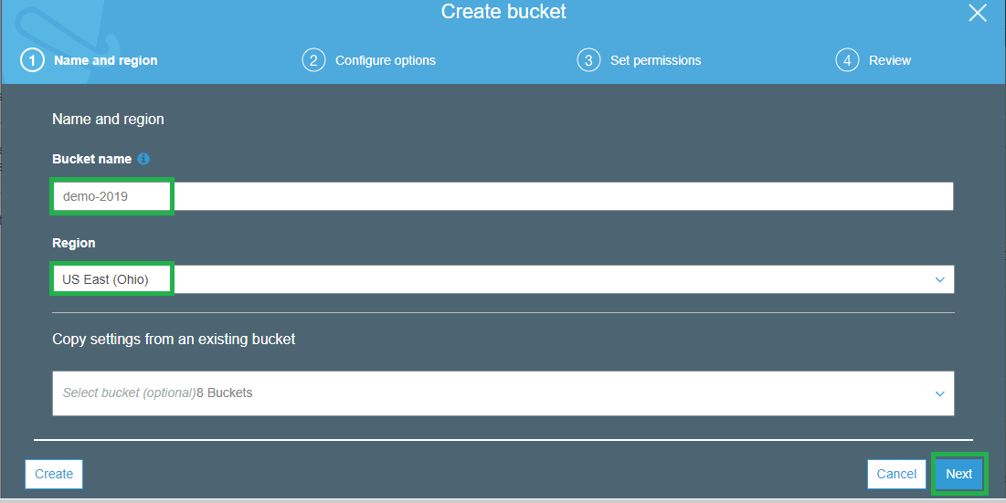

1. Keep the default settings and click Next

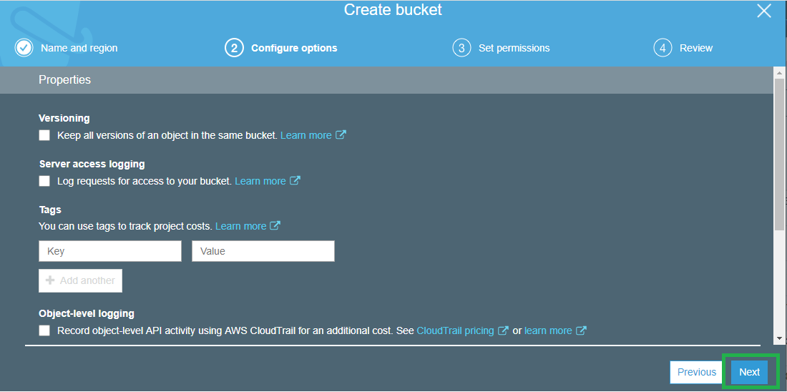

1. To block public access for this bucket enable the block. If you are creating this bucket to host public accessed files then keep this disabled.

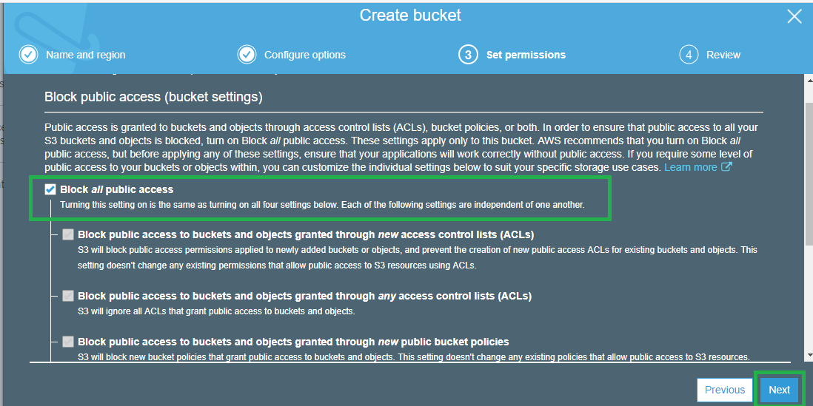

1. Click create to create the new bucket.

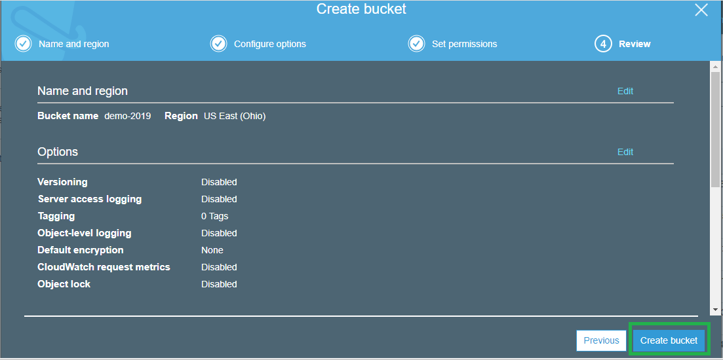

1. Verify access of the bucket. In this case the bucket public access is enabled.

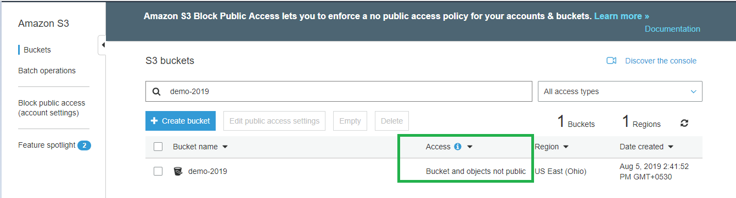

1. To upload objects to the newly create bucket, click the bucket and click upload files option.

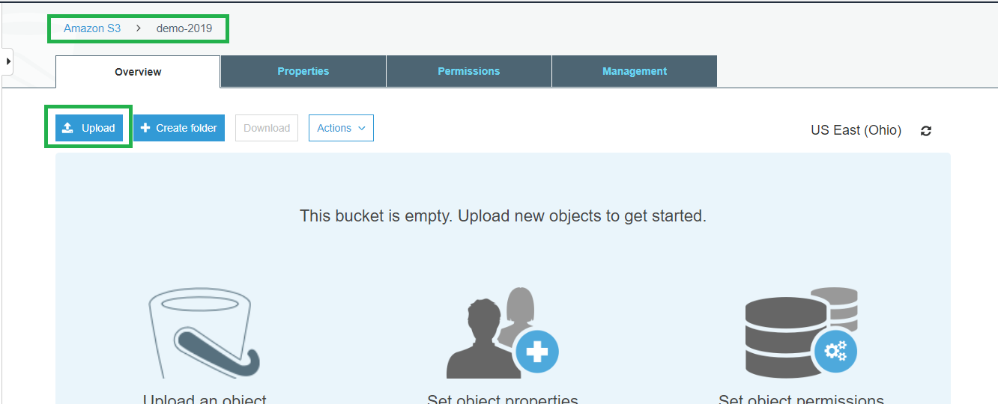

1. Add files to upload and click upload and click next.

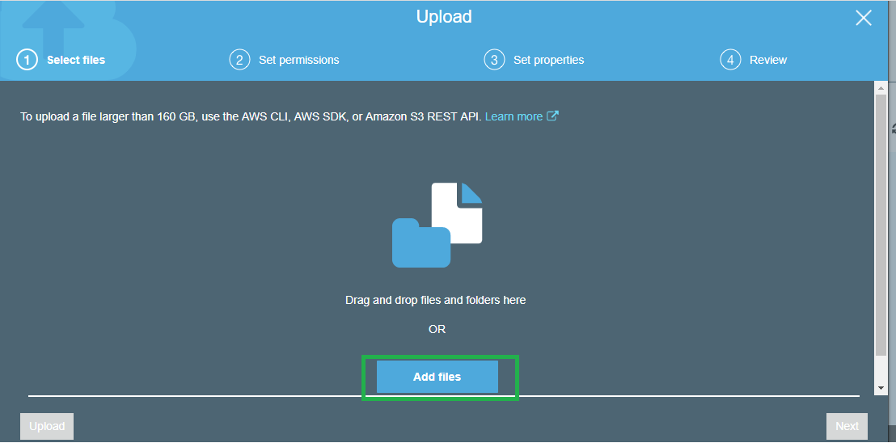

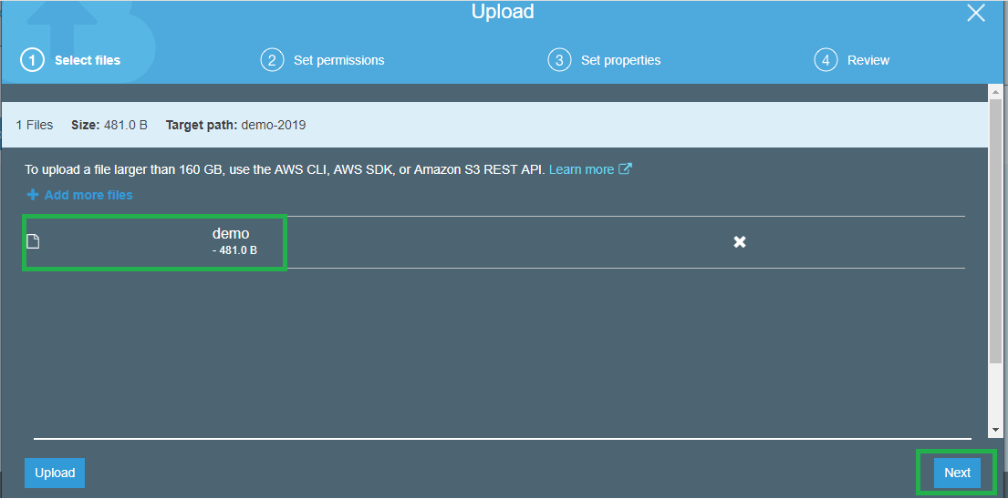

1. If the objects require public access then enable otherwise leave it as default which is do not grant public access.

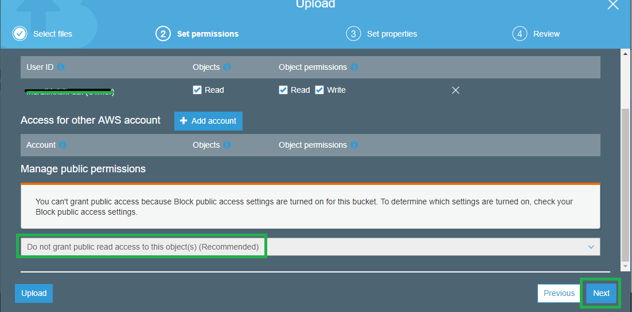

1. Select the storage tier as required. Otherwise keep the default tier and click next.

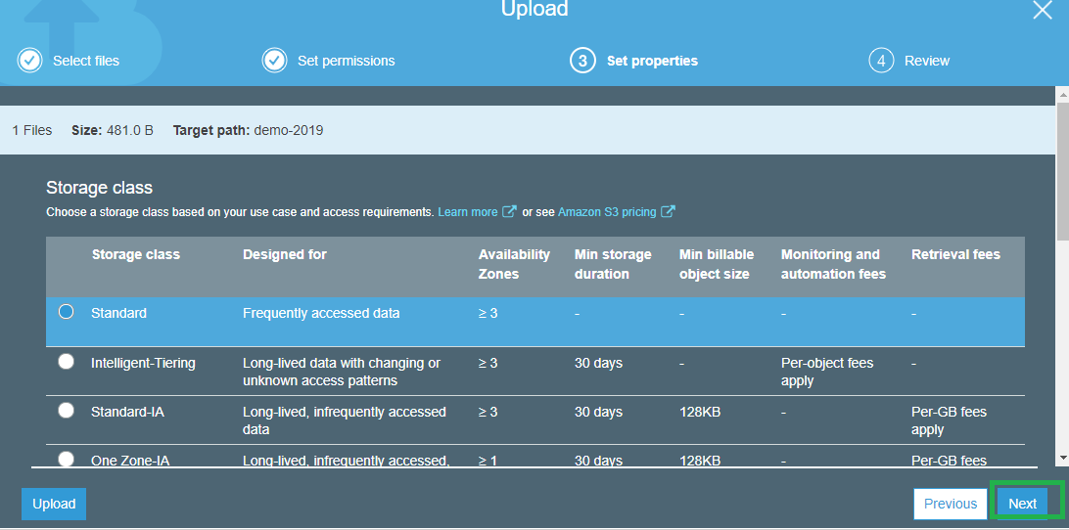

1. Click upload to start the objects upload to the new bucket.

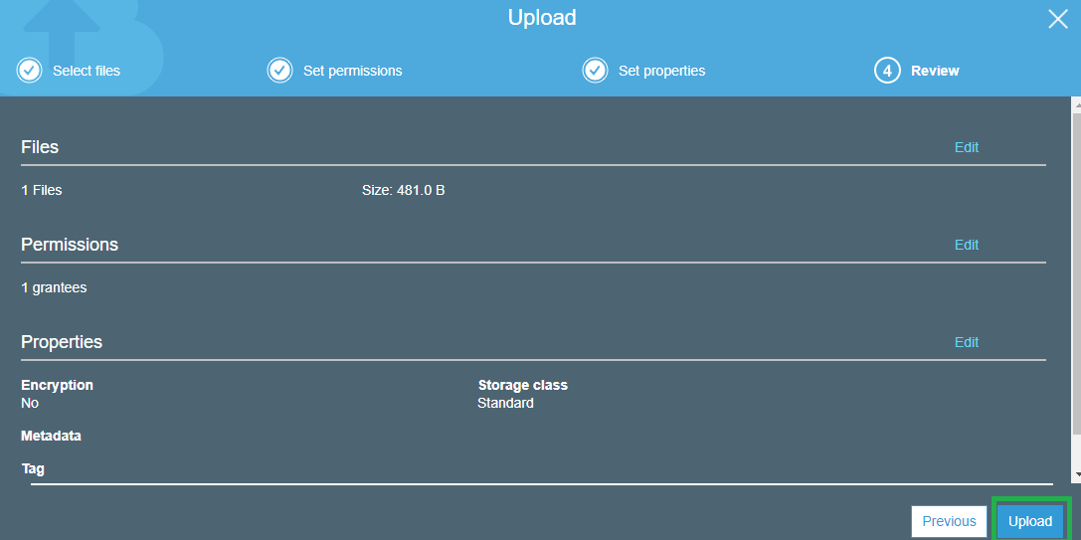

1. The upload is complete now and the file can be seen inside the bucket.

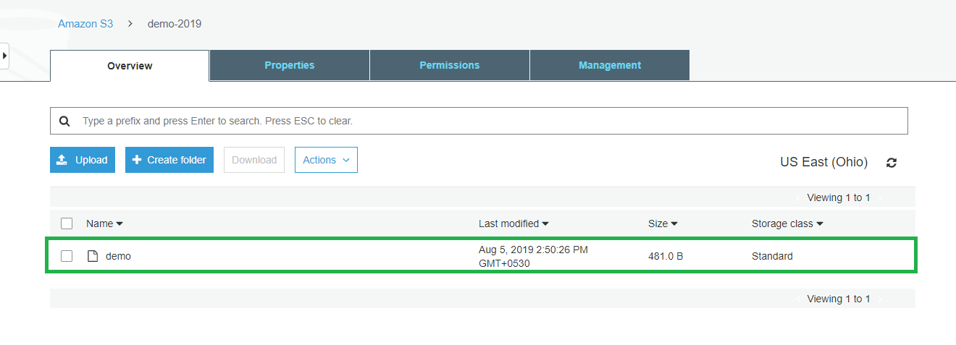

1. The file can be viewed or downloaded using open or download options. Each file also have an object URL using which the file can be accessed over browser.

